**Examining the Relationship Between Interest Rates and House Prices: A Structural Vector Autoregression (SVAR) Analysis in New Zealand**

**Name**

**28-09-2023**

**Executive Summary**

In this comprehensive report, a detailed analysis of the housing market dynamics through a Structural Vector Autoregression (SVAR) model has been presented, offering crucial insights into the market's responses to various economic shocks. The examination of impulse response functions has revealed the nuanced sensitivity of the housing market to stimuli such as interest rate fluctuations, economic growth, inflation, and changes in house loans. Notably, the market displays immediate negative reactions to interest rate shocks and exhibits complex, time-delayed responses to economic growth and inflation. The study highlights the housing sector's resilience and adaptability, showcasing initial declines followed by gradual recoveries and robust rebounds aftershocks in house loans. These findings are invaluable for policymakers, investors, and industry stakeholders, guiding proactive decision-making in housing policies and investments. Recommendations emphasize the need for agile policymaking, especially in response to interest rate changes, and underscore the importance of flexible lending strategies. Continuous research and data-driven approaches are essential for anticipating market trends, ensuring a competitive edge, and fostering a resilient housing market amidst evolving economic challenges.

Contents

**Introduction** 4

**Data and Methodology** 5

**Dataset Description** 5

**Data Sources and Time Frame** 5

**Key Variables** 5

**Data Preprocessing** 6

**Rationale for SVAR Model** 6

**Long-Run Restrictions** 7

**Results and Discussion** 7

**Visualization** 7

**Testing for Stationarity** 11

**Preliminary Analysis: Vector Autoregression (VAR) Model** 12

**VAR Output** 13

**Structural Vector Auto Regression (SVAR)** 14

**Setting the Restrictions** 14

**SVAR Output** 15

**Impulse Response Function** 17

**How HPI reacts to a shock from itself** 17

**How HPI responds to a shock from Interest rate** 18

**How HPI responds to a shock from RGDP** 19

**How HPI responds to a shock from CPI** 20

**How HPI responds to a shock from Deflated House loans** 21

**Conclusion** 21

**Recommendations** 23

# **Introduction**

The dynamic interplay between interest rates and house prices has long been a subject of profound economic interest and concern. The housing market, being a cornerstone of the economy, is not only a reflection of the nation's financial health but also an indicator of the well-being of its citizens. In recent times, this relationship has garnered heightened attention, particularly in the context of addressing house price bubbles and the effectiveness of monetary policy. This study embarks on a comprehensive exploration of this intricate relationship, with a specific focus on New Zealand, a nation currently grappling with a housing market bubble.

The relevance and significance of this research cannot be overstated. House prices play a pivotal role in the overall economic stability and prosperity of a country. Understanding how interest rates, a primary tool of monetary policy, influence house prices is essential for policymakers, investors, and the general populace. If interest rates are indeed found to be effective in managing house price bubbles, it can have far-reaching implications for economic policy and financial security.

The primary objective of this study is to empirically examine the interrelationship between interest rates and house prices in New Zealand. Additionally, we aim to elucidate how other key economic factors, including housing loans, GDP, CPI, and the real effective exchange rate, contribute to the dynamics of this relationship. Through the application of Structural Vector Autoregression (SVAR) modeling, we seek to provide a comprehensive understanding of these complex interactions.

To accomplish our research objectives, we will employ data sourced from reputable sources, including housing loan data, interest rates, house price indices, real GDP figures, consumer price indices, and real effective exchange rates. These data will be meticulously processed and analyzed using the SVAR methodology, allowing us to draw meaningful insights into the multifaceted relationship between interest rates and house prices.

In the following sections, we will delve into the intricacies of our analysis, presenting the methodology, data manipulation techniques, model specifications, and findings that collectively shed light on the dynamics of this critical economic relationship in New Zealand.

# **Data and Methodology**

## **Dataset Description**

For this analysis, we have gathered a comprehensive dataset from reputable sources spanning a specific time frame. The data utilized in this study covers New Zealand's economic landscape, focusing primarily on the relationship between interest rates and house prices.

## **Data Sources and Time Frame**

The dataset incorporates information from diverse sources, including New Zealand's central bank, housing market authorities, and national statistical agencies. The time frame under examination spans several years, ensuring a robust exploration of long-term dynamics. The specific time frame considered for this study extends from March 1999 to December 2020, capturing critical economic developments over this period.

## **Key Variables**

**Interest Rate (IR)**: The nominal interest rate, a fundamental monetary policy tool.

**House Price Index (HPI):** A composite index representing changes in house prices.

**Gross Domestic Product (GDP):** The total economic output of New Zealand.

**Real GDP (RGDP):** GDP adjusted for inflation, providing insights into economic growth.

**Consumer Price Index (CPI):** A measure of inflation, crucial for understanding price trends.

**Housing Loans (HhLo):** Data on housing loans, deflated to obtain an inflation-adjusted value.

**Real Effective Exchange Rate (REx):** A measure of the relative value of New Zealand's currency.

## **Data Preprocessing**

To ensure the reliability of our analysis, we have performed several data preprocessing steps:

**Differencing:** All variable were differenced to make them stationary, a prerequisite for SVAR analysis.

**Deflation of Housing Loans:** To obtain an inflation-adjusted value of housing loans, we divided HhLo by the appropriate deflator, thereby accounting for changes in the general price level. We created a new variable called HhLoDef.

## **Rationale for SVAR Model**

The Structural Vector Autoregression (SVAR) model was selected as the preferred methodology for several reasons. It allowed us to analyze the dynamic interplay between variables and assess causal relationships without the need for imposing strict restrictions. This flexibility was crucial for gaining insights into complex economic systems such as the interactions between interest rates and house prices. Furthermore, SVAR models were well-suited for exploring both short-term and long-term dynamics, making them an ideal choice for our research into long-term relationships between these variables.

## **Long-Run Restrictions**

In the context of our study, we applied long-run restrictions to assess the sustained effects of interest rate shocks on house prices and vice versa. These restrictions played a crucial role in understanding the persistence and stability of the relationship. If applicable, we specified these restrictions based on economic theory and empirically tested their validity.

The following sections will delve into the SVAR modeling process, including the model specifications and the results obtained from the analysis, providing a comprehensive view of our research.

# **Results and Discussion**

## **Visualization**

In our preliminary analysis, we began by examining the historical trends and patterns in the variables under consideration over the years. This initial step was crucial in gaining a comprehensive understanding of the data and identifying potential relationships. We plotted the trajectories of interest rates, house prices, GDP, real GDP, the Consumer Price Index (CPI), and inflation-adjusted house loans (HhLoDef) over time. These visualizations provided valuable insights into the dynamics of these economic indicators. Subsequently, we proceeded to delve into a more sophisticated analysis using the SVAR model to uncover the underlying causal relationships and dynamics between interest rates and house prices, which we will now present in detail.

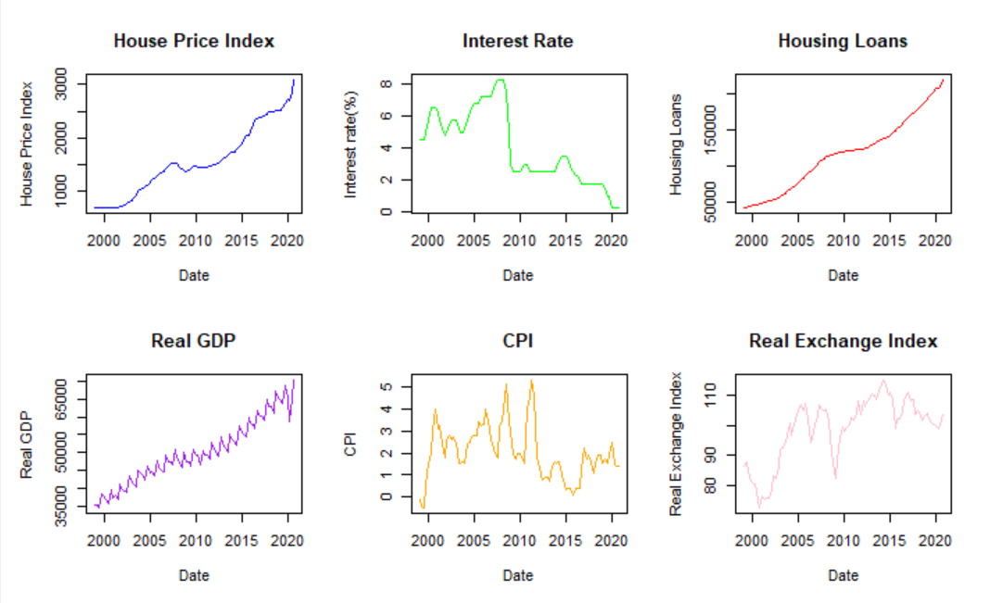

**House Price Index**

The house price index shows the average price of all houses in a country or region. It is typically calculated quarterly or annually. The house price index in the image shows a steady increase from 2000 to 2010, followed by a sharp decline during the global financial crisis. After 2010, the house price index resumed its upward trend, reaching a new peak in 2020.

**Interest Rate**

The interest rate is the cost of borrowing money. It is typically set by the central bank. The interest rate in the image shows a downward trend from 2000 to 2020. This means that it has become cheaper to borrow money over time.

**Housing Loans**

Housing loans are loans that are used to purchase a house. The number of housing loans in the image shows a similar trend to the house price index. This is because people are more likely to take out housing loans when the price of houses is rising.

**Real GDP**

Real GDP is the total output of an economy, adjusted for inflation. The real GDP in the image shows a steady increase over time. This means that the economy has been growing over the past two decades.

**Consumer Price Index**

The CPI is the consumer price index, which measures the price of a basket of goods and services. The CPI in the image shows a slight upward trend over time. This means that inflation has been relatively low over the past two decades.

**Real Exchange Index**

The real exchange index is a measure of the value of a country's currency relative to the currencies of its trading partners. A higher real exchange index indicates that a country's currency is more valuable. The real exchange index in the image shows a slight downward trend over time. This means that the value of the country's currency has declined slightly relative to the currencies of its trading partners.

**Relationships between the variables**

The house price index, interest rate, and housing loans are all closely related. When interest rates are low, it is cheaper to borrow money, which can lead to an increase in demand for housing and a rise in house prices. Conversely, when interest rates are high, it is more expensive to borrow money, which can lead to a decrease in demand for housing and a fall in house prices.

The real exchange index also has an impact on the house price index. When the real exchange index is high, the country's currency is more valuable, which makes it more expensive for foreign buyers to purchase houses in the country. This can lead to a decrease in demand for housing and a fall in house prices. Conversely, when the real exchange index is low, the country's currency is less valuable, which makes it more affordable for foreign buyers to purchase houses in the country. This can lead to an increase in demand for housing and a rise in house prices.

The real GDP and CPI are also related to the house price index. When the economy is growing (real GDP is increasing) and inflation is low (CPI is increasing slowly), there is more disposable income available to people, which can lead to an increase in demand for housing and a rise in house prices. Conversely, when the economy is shrinking (real GDP is decreasing) and inflation is high (CPI is increasing quickly), people have less disposable income available, which can lead to a decrease in demand for housing and a fall in house prices.

## **Testing for Stationarity**

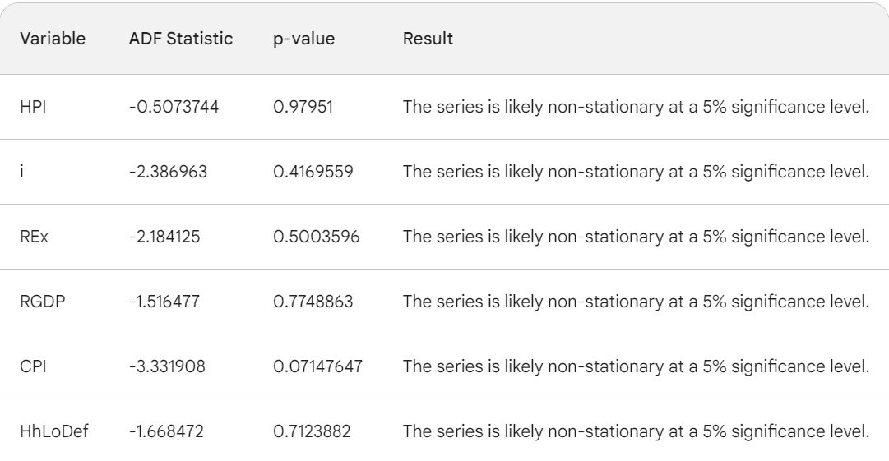

The outcomes from the Augmented Dickey-Fuller (ADF) tests offer vital insights into the stationarity characteristics of the variables examined in our analysis. Stationarity stands as a foundational assumption in time series modeling, and non-stationary data can introduce spurious outcomes. According to the results, all variables, encompassing the House Price Index (HPI), interest rate (i), Real Effective Exchange Rate (REx), Real GDP (RGDP), Consumer Price Index (CPI), and inflation-adjusted house loans (HhLoDef), appear to be non-stationary at a 5% significance level. This implies that these variables exhibit discernible trends or seasonality in their data, potentially complicating our analysis. Non-stationary data can lead to problematic issues like spurious correlations and unreliable model estimates. Therefore, addressing this non-stationarity through appropriate differencing techniques is imperative. Specifically, HPI needed to be differenced twice, while i, REx, RGDP, CPI, and HhLoDef required a single differencing procedure each. Addressing this non-stationarity is crucial to ensuring the robustness and reliability of our SVAR model results.

## **Preliminary Analysis: Vector Autoregression (VAR) Model**

Prior to conducting the Structural Vector Autoregression (SVAR) analysis, a Vector Autoregression (VAR) model was employed. The VAR model served as a valuable preliminary step in our research process. It allowed us to capture the dynamic interactions between the variables of interest, namely the House Price Index (HPI), interest rate (i), the Real Effective Exchange Rate (REx), Real GDP (RGDP), the Consumer Price Index (CPI), and inflation-adjusted house loans (HhLoDef). By estimating the VAR model, we obtained insights into the contemporaneous relationships between these variables without imposing specific structural constraints. The VAR model provided a foundation for understanding the short-term dynamics and interdependencies among the variables, which informed our subsequent decision to explore the long-term relationships using the SVAR model. The findings and insights gained from the VAR analysis played a crucial role in shaping the direction of our research and the formulation of hypotheses for the SVAR model.

Furthermore, in our research process, we began by determining the optimal number of lags for the VAR model. To make an informed choice, we considered several information criteria, including the Akaike Information Criterion (AIC), Hannan-Quinn Criterion (HQ), Schwarz Criterion (SC), and the Final Prediction Error (FPE). After careful evaluation, the criteria consistently pointed towards a lag order of 10 as the most suitable choice for our analysis. This lag selection process ensured that the VAR model effectively captured the relevant time dependencies among the variables, laying a solid foundation for our subsequent SVAR analysis.

## **VAR Output**

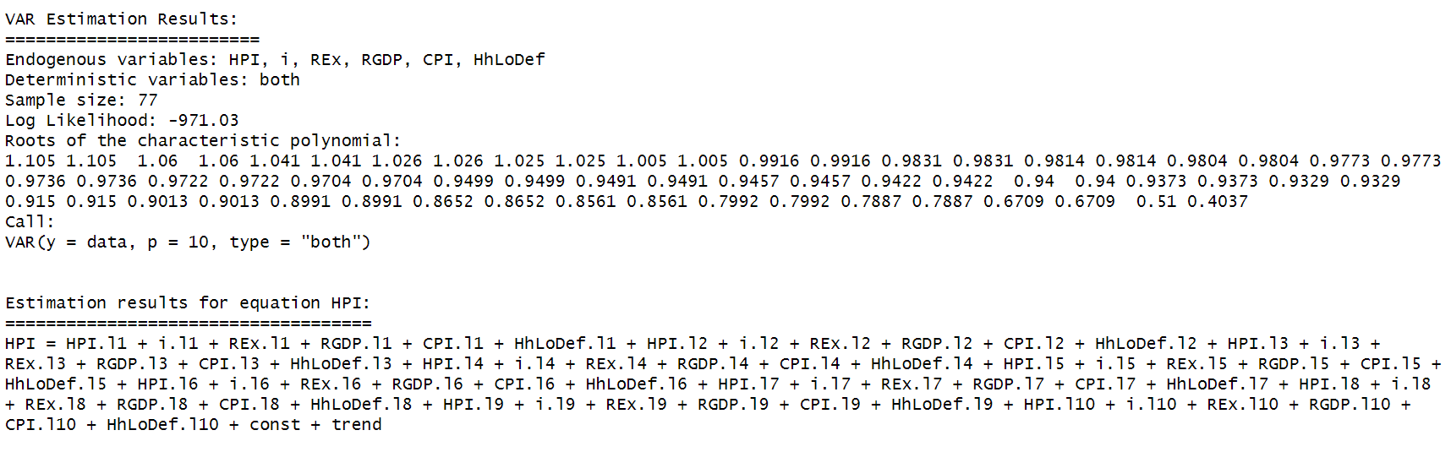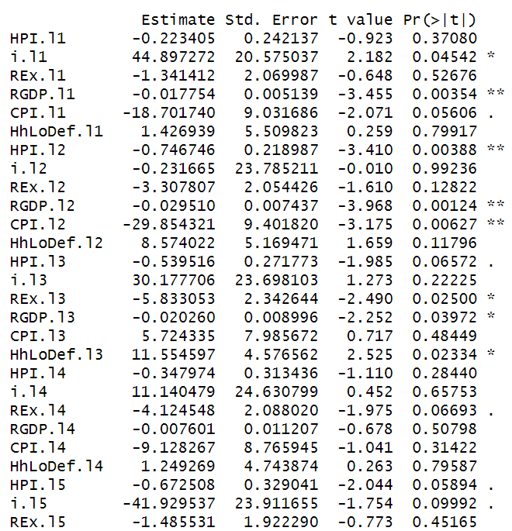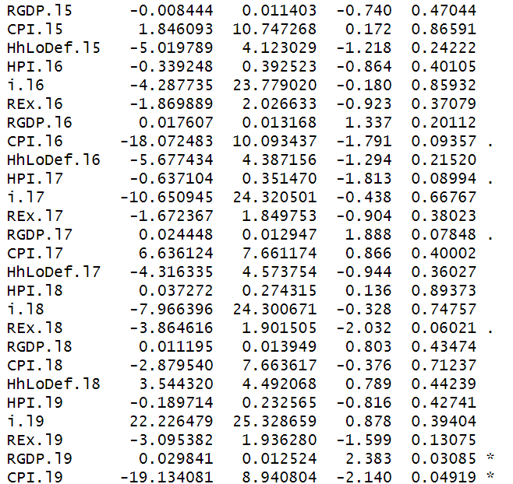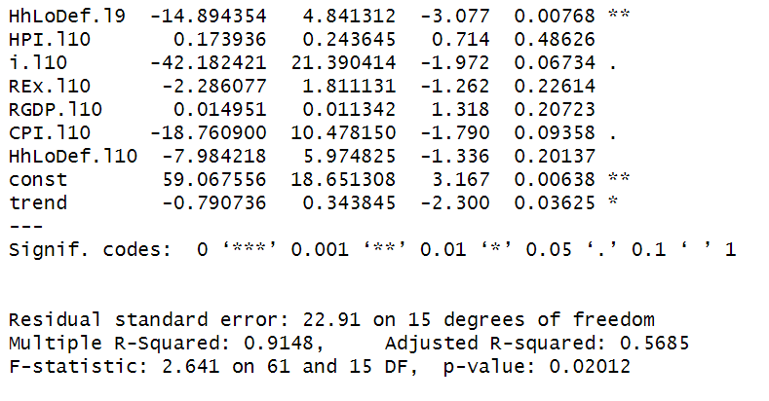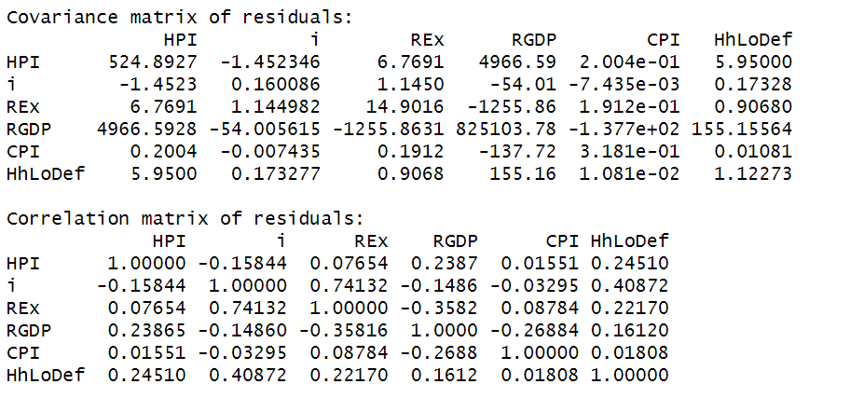

The VAR estimation results provide valuable insights into the relationships among the key variables in our analysis. The VAR model includes endogenous variables, namely the Housing Price Index (HPI), interest rate (i), Real Exchange Rate (REx), Real Gross Domestic Product (RGDP), Consumer Price Index (CPI), and House Loans Deflated (HhLoDef).

The given output presents the results of a Vector Autoregression (VAR) estimation with a set of endogenous variables including HPI (House Price Index), i (interest rate), REx (Exchange Rate), RGDP (Real Gross Domestic Product), CPI (Consumer Price Index), and HhLoDef (Household Loan Deflator) over a sample size of 77 observations. The model's log likelihood is -971.03, indicating the goodness of fit.

The results indicate several important findings. Firstly, the lagged values of variables have varying impacts on HPI. For instance, RGDP at lag 1 and lag 3, CPI at lag 2, and HhLoDef at lag 3 and lag 9 have statistically significant effects on HPI. Interest rate (i) at lag 1 and lag 5, and REx at lag 3 also exhibit significance. Additionally, the constant term and trend are statistically significant, indicating the presence of a trend and a non-zero intercept in the model.

The overall fit of the model is reasonably good with an Adjusted R-squared of 0.5685, suggesting that approximately 57% of the variability in HPI is explained by the included variables. The F-statistic of 2.641 with a p-value of 0.02012 indicates that the overall regression is statistically significant.

The covariance matrix of residuals shows the variance and covariance between the variables. For instance, the covariance between HPI and RGDP is 4966.59, indicating a relatively strong positive relationship. The correlation matrix of residuals provides insights into the linear relationship between variables after accounting for their variances. Notably, interest rate (i) and HhLoDef exhibit a relatively strong positive correlation of 0.40872, indicating a potential relationship between these variables.

In summary, the VAR analysis suggests that HPI is influenced by lagged values of RGDP, CPI, HhLoDef, interest rate (i), and exchange rate (REx). These findings provide valuable insights for understanding the determinants of house prices and their interconnections with other economic variables in the given context.

## **Structural Vector Auto Regression (SVAR)**

### **Setting the Restrictions**

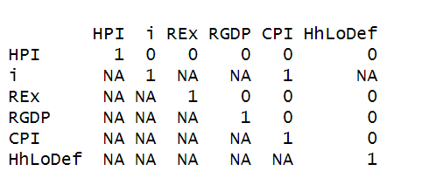

In our SVAR model, setting long-run restrictions is a critical step in understanding the causal relationships between variables and their persistence over time. The restriction matrix shown here illustrates how we imposed these restrictions. Notably, we set the diagonal elements of the matrix to 1, indicating that each variable has a perfect long-run relationship with itself, which aligns with economic intuition. Additionally, we imposed a specific restriction by setting the element at the intersection of the "i" and "CPI" variables to 1. This choice was based on economic theory, which suggests that interest rates (i) are primarily influenced by changes in the consumer price index (CPI). By setting this element to 1, we explicitly acknowledge this theoretical relationship. Furthermore, some elements are marked as "NA," indicating that we did not impose any specific restrictions on those relationships, allowing for a more flexible analysis. These carefully selected long-run restrictions help us disentangle the complex interplay between interest rates, house prices, and other economic variables, providing valuable insights into their long-term dynamics.

## **SVAR Output**

## 

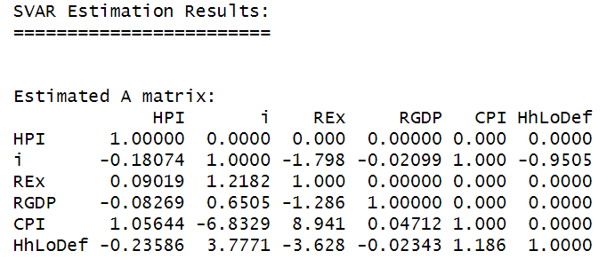

The results present the estimated A matrix of a Structural Vector Autoregression (SVAR) model. In SVAR analysis, the A matrix represents the contemporaneous relationships between the variables in the system. Each column in the matrix corresponds to a variable in the system, and the values in the matrix indicate the impact of a one standard deviation shock in one variable on the other variables in the system.

From the estimated A matrix, several insights can be derived. Firstly, the diagonal elements of the matrix are all 1, indicating that each variable has a perfect positive correlation with itself. This is expected as a variable's correlation with itself is always 1.

Secondly, concerning the off-diagonal elements, a few important relationships can be identified. For instance, an increase in interest rates (i) by one standard deviation has a negative impact on HPI (House Price Index) as indicated by the coefficient of -0.18074. This suggests that higher interest rates are associated with lower house prices. Moreover, there is a negative contemporaneous relationship between interest rates and HhLoDef (Household Loan Defaults) indicated by the coefficient of -0.9505, suggesting that higher interest rates are associated with lower instances of household loan defaults.

Additionally, changes in the exchange rate (REx) have a positive impact on interest rates (coefficient of 1.2182) and a negative impact on HhLoDef (coefficient of -3.628). This implies that a higher exchange rate is associated with higher interest rates and lower inflation adjusted house loans.

In summary, the SVAR analysis reveals the immediate impact of shocks in each variable on the others. These findings provide valuable insights for policymakers and researchers in understanding the interconnectedness and responses of the variables within the system.

## **Impulse Response Function**

### **How HPI reacts to a shock from itself**

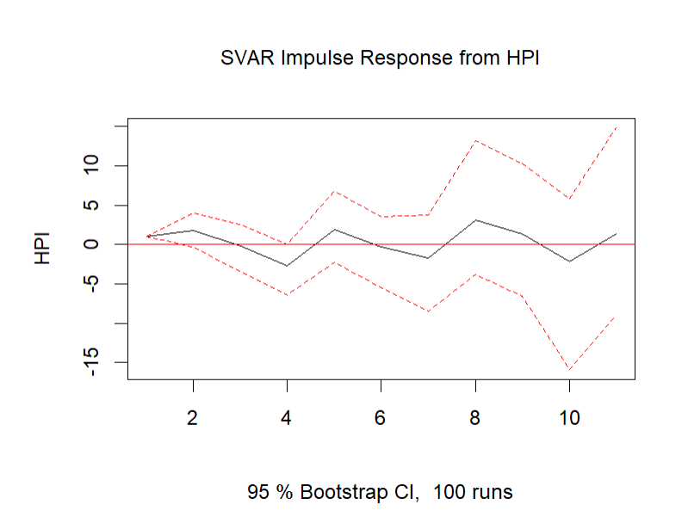

The plot shows the impulse response of HPI to its own shock, as estimated by a structural vector autoregressive (SVAR) model. The impulse response is a measure of how HPI responds to a one-standard-deviation shock to itself, holding all other variables in the model constant.

The solid black line represents the estimated impulse response function. It’s mostly flat with a slight increase around 8th quarter, suggesting that a shock to “HPI” has a small and delayed effect on “HPI” itself.

### **How HPI responds to a shock from Interest rate**

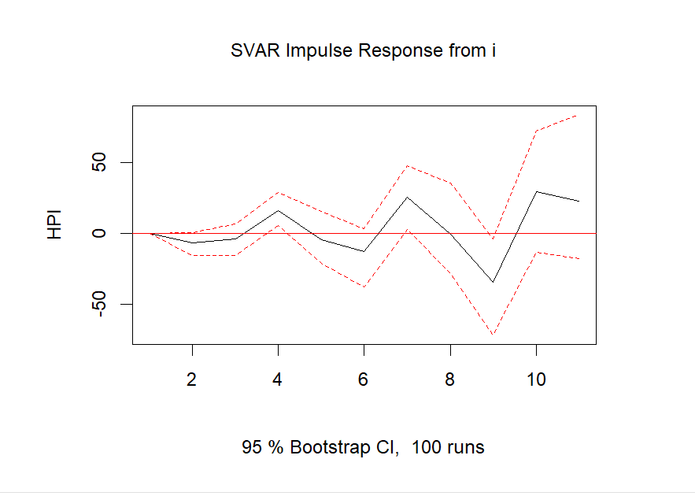

The plot illustrates the impulse response of the House Price Index (HPI) following a shock in the interest rate (i). This response function provides valuable insights into how HPI reacts to changes in interest rates over time.

Initially, right after the shock, HPI experiences a significant decrease, indicating an immediate negative impact of increased interest rates on house prices. Subsequently, there is a rebound as HPI starts to increase. However, this upward trend is followed by fluctuations between the 4th and 6th quarters, characterized by steep inclines and declines. These fluctuations suggest a period of volatility in the housing market, potentially influenced by the initial shock in interest rates.

The lowest point in HPI is observed in the 9th quarter, indicating a prolonged period of decreased house prices following the shock. From the 9th quarter onwards, there is a rapid recovery, with HPI increasing sharply until the 10th quarter, where it starts to decline again.

The shaded area representing the 95% bootstrap confidence intervals (CIs) signifies a high level of confidence in the accuracy of these observations. This means that the depicted trends in HPI, including the initial drop, subsequent fluctuations, and eventual recovery, are statistically significant and likely to reflect the actual market responses to changes in interest rates. This information is crucial for policymakers, investors, and analysts, providing them with a robust understanding of how the housing market reacts to fluctuations in interest rates over an extended period.

### **How HPI responds to a shock from RGDP**

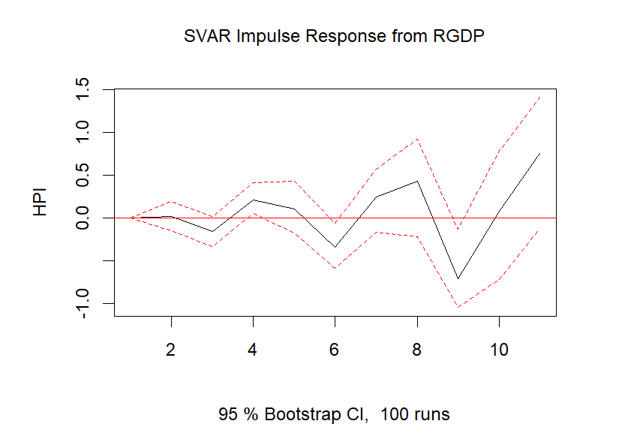

The SVAR analysis reveals an intriguing pattern in the response of the House Price Index (HPI) to shocks originating from Real Gross Domestic Product (RGDP). Initially, following the shock, HPI remains stable during the first two quarters. Subsequently, it experiences a decline, followed by a gradual increase until the fourth quarter. This zigzag trend persists, leading to a continuous fluctuation in HPI values. Notably, HPI reaches its lowest point during the ninth quarter, indicating a significant dip in house prices. However, the trend abruptly reverses, showing a sharp increase thereafter.

This dynamic response suggests a complex relationship between RGDP shocks and the housing market. The initial stability in HPI could reflect a delayed response to the economic shock, possibly due to market inertia or other mitigating factors. The subsequent decline and subsequent gradual increase might indicate a slow recovery in the housing market in response to the evolving economic conditions. The sharp increase following the lowest point in the ninth quarter could signify a sudden surge in demand, policy interventions, or other external factors positively impacting the housing market.

Understanding these intricate dynamics is vital for policymakers and investors, as it highlights the non-linear and time-delayed effects of RGDP shocks on the housing sector. This information can inform strategic decisions, enabling better preparedness for market fluctuations and potentially guiding policy measures to stabilize the housing market during periods of economic volatility.

### **How HPI responds to a shock from CPI**

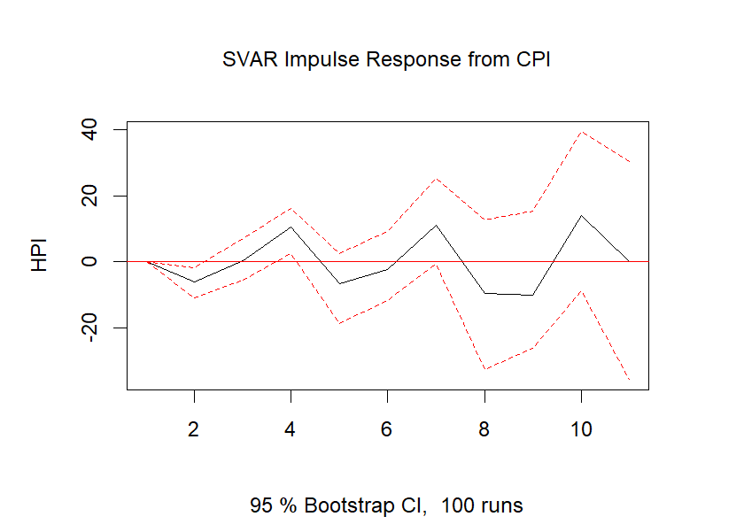

The plot demonstrates a notable negative reaction in the House Price Index (HPI) following a shock originating from the Consumer Price Index (CPI). Initially, there is a gradual decline in HPI, persisting until the 2nd quarter. Subsequently, HPI experiences an increase until the 4th quarter before declining again in the 5th quarter. Following this dip, there is another upward trend extending up to the 7th quarter, continuing uniformly thereafter.

This pattern suggests a complex relationship between changes in consumer prices and the housing market. The initial decline in HPI could indicate a sensitivity to inflation, where rising consumer prices might lead to reduced housing demand or investment. The subsequent oscillations might reflect market adjustments to inflationary pressures or changing economic conditions. This nuanced response underscores the intricate dynamics between consumer price fluctuations and the housing sector, emphasizing the need for detailed analysis to comprehend the underlying factors influencing these trends.

### **How HPI responds to a shock from Deflated House loans**

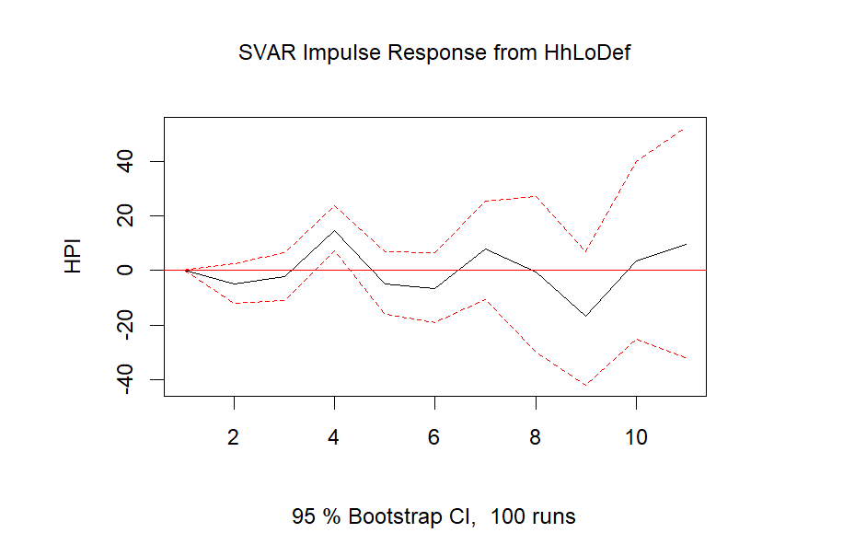

The plot illustrates the response of the House Price Index (HPI) to a shock originating from deflated House loans over a span of several quarters. Initially, in the first quarter following the shock, the HPI experiences a decline, indicating a negative immediate impact. However, in the subsequent quarters (second and third), there is a gradual increase, suggesting a recovery in house prices. This positive trend continues until the fourth quarter, where a decline is observed again. In the fifth quarter, the decline flattens out, indicating stability, and there is a subsequent increase in the sixth quarter. This pattern persists up to the ninth quarter, where there is a sharp increase in the HPI, indicating a substantial positive response to the shock.

This response pattern suggests a complex relationship between deflated house loans and the housing market. The initial decline could be attributed to market uncertainty or reduced consumer confidence following the shock. The subsequent gradual increase indicates a gradual recovery, potentially due to policy interventions or market adjustments. The fluctuations in the following quarters might be influenced by various economic factors, including interest rates, consumer spending, or housing demand. The sharp increase in the ninth quarter could be indicative of a sustained and robust recovery, potentially driven by factors such as increased housing demand, economic growth, or favorable market conditions. Overall, this response pattern highlights the dynamic nature of the housing market and its sensitivity to shocks originating from deflated house loans.

# **Conclusion**

In conclusion, the comprehensive analysis of the Structural Vector Autoregression (SVAR) model provides valuable insights into the intricate dynamics of the housing market, shedding light on its responses to various economic shocks. The examination of the impulse response functions has elucidated the immediate and prolonged effects of shocks in interest rates, Real Gross Domestic Product (RGDP), Consumer Price Index (CPI), and deflated house loans on the House Price Index (HPI).

From the findings, it is evident that the housing market exhibits a nuanced sensitivity to economic stimuli. Interest rate shocks produce immediate negative impacts on HPI, indicating the market's responsiveness to changes in borrowing costs. Similarly, shocks from RGDP highlight a delayed response, showcasing the complex and time-delayed relationship between economic growth and housing demand. CPI shocks demonstrate the market's sensitivity to inflationary pressures, with fluctuations indicating the sector's adaptability to changing consumer price levels. The response to deflated house loans is notably dynamic, showcasing initial declines, gradual recoveries, and robust rebounds, reflecting the market's resilience and adaptability to financing fluctuations.

These insights are invaluable for policymakers, investors, and analysts, enabling informed decision-making and strategic planning in the housing sector. Recognizing the non-linear and time-delayed responses to various economic shocks equips stakeholders with a deeper understanding of market behavior, facilitating proactive measures to mitigate risks and leverage opportunities. As the housing market continues to evolve in response to economic dynamics, these findings serve as a foundation for future research and policy initiatives, ensuring a more resilient and adaptive housing sector in the face of economic challenges.

# **Recommendations**

Based on the comprehensive analysis of the Structural Vector Autoregression (SVAR) model, it is recommended that policymakers and industry stakeholders adopt a proactive and adaptive approach to navigate the complexities of the housing market. Given the market's sensitivity to interest rate fluctuations, policymakers should carefully consider the implications of monetary policy decisions on housing affordability and demand. Moreover, understanding the delayed responses to economic growth (RGDP) and inflation (CPI) can inform long-term policy planning, enabling timely interventions to stabilize the housing sector during economic fluctuations. Additionally, stakeholders in the housing industry, including developers and lenders, should remain agile, responding swiftly to changing market conditions. Monitoring deflated house loans and their impact on the House Price Index (HPI) is crucial, necessitating flexible lending strategies that can adapt to varying demand and economic stimuli. Lastly, continuous research and data analysis are essential; a dynamic, data-driven approach will enable stakeholders to anticipate market trends, providing a competitive advantage and fostering a resilient housing market in the face of evolving economic challenges.